1. [Home](https://www.cmh.org/)
2. » Transformation CMH

TRANSFORMATION CMH

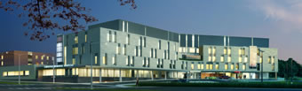

Welcome to “Transformation CMH,” where you will find information and updates about our new hospital build. [Click here to see the latest webcam photo](http://ucitonline.com/cambridgememorial/) (updated every 15 minutes)

YES! A brand new hospital for the residents of Cambridge and North Dumfries is well udner way. The construction comprises a new patient care tower and complete renovation of the existing patient care wing, which will provide the necessary space for CMH to bring new and expanded clinical services to our community.

In total, the project includes 240,000 square feet of new construction and 150, 000 square feet of renovations to the current Wing B. The total cost of the project is valued at about $187 million.

A community component for funding the Cambridge Memorial Hospital Capital Redevelopment Project has been raised by the Region of Waterloo, the City of Cambridge and the community through the One Voice, One Vision campaign. Additional funds to purchase the crucial life-saving technology and equipment that is needed to fill this essential expansion are needed. Please contact the [CMH Foundation](http://www.cmhfoundation.ca/)for more information.